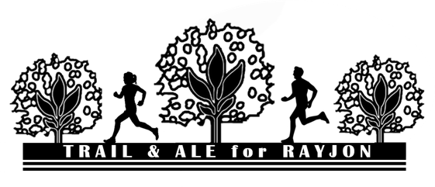
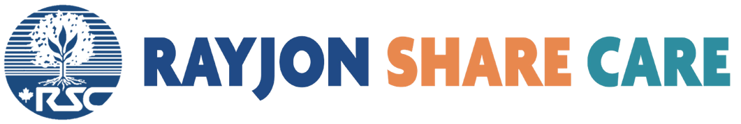
PLEASE PRINT CLEARLY

PLEDGE SHEET

# | Last Name | First Name | Street Address | City | Prov. | Postal Code | Phone # | Email *  (for tax receipt) | Donation Amount ($) | Rec’d
0 | Smith | John | 123 Main St. | Sarnia | ON | N7T 1V1 | 333-333-3333 | jsmith@template.com | $$$

1

2

3

4

5

6

7

8

9

10

 |  |  |  |  |  |  |  | TOTAL PAGE ONE

For more information contact Rayjon Share Care (519)381-5929 or info@rayjon.org

Thank you for helping us support families in Haiti & the Dominican Republic!

Donations of $20 or more will receive a tax receipt.
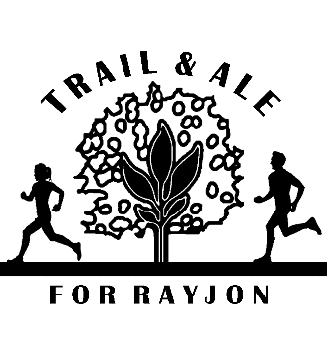

PLEASE PRINT CLEARLY
PLEDGE SHEET- PAGE 2

# | Last Name | First Name | Street Address | City | Prov. | Postal Code | Phone # | Email *  (for tax receipt) | Donation Amount ($) | Rec’d

11

12

13

14

15

16

17

18

19

20

 |  |  |  |  |  |  |  | TOTAL PAGE 2
 |  |  |  |  |  |  |  | GRAND TOTAL

For more information contact Rayjon Share Care (519)381-5929 or info@rayjon.org

Thank you for helping us support families in Haiti & the Dominican Republic!

Donations of $20 or more will receive a tax receipt.

